Our Time of Trial is Coming
March 31st, 2022

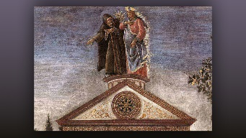
God, we ask for Your wisdom and perspective during our times of trials. Please provide it generously and show us how to see our circumstances through Your eyes. Amen.

“My dear family,” Mother Clare began, “Our Mother of Mercy has asked me to tell you all about the messages I was getting in Florida, when she first began to speak to me. We had a small prayer group, of medical professionals from the Philippines, that faithfully attended the Rosary. During this time, Our Mother of Mercy was speaking to us about the evils of materialism and how it has corrupted our nation. She asked them to pay off their debts and live much more simply without credit cards, etc.

“And now with war on the horizon, she has asked me to speak with you about these very same issues. The Lord has made it clear that war is imminent and could even begin this month, on our own soil. The casualties will be heart breaking, but Americans are about to be stripped of the excessive lifestyle and materialism, so they can discover what is truly important in their lives.

“In many ways this is an act of mercy to pull people away from their addictions to things so they can embrace Jesus like they have never embraced Him before. There is a spiritual equipping coming to us so that we can lead them in the ways of God. Their sense of self-worth is tied up in these things, and Jesus wants them to discover how very precious they are without all the trappings, just as they are, without any status symbols, power or influence. He is going to allow a stripping away of all the measurements of human worth they have become prisoners to.

“Many of us are bound by possessions and desires for more things, upgrades and new apps, etc., when what we have would do just as well for us. It is a whole culture that has been seduced by technology and staying on the cutting edge. It has left many in debt way over their heads. Our lives have become so full of the world that we don’t have time for God, and yet He is at the core of our very existence.

“When we are stripped of everything we hold dear, things we have labored for years to have, we will discover God and His all-encompassing love for us, and that is truly the fulfillment of life, to belong to Jesus, to walk with Him, talk with Him and depend on Him for our food and sustenance. During this great trial we will finally have a need for God that breaks us away from all that we have and count as important in our lives.

“I have resigned myself that Jesus is enough, but I am much weaker than I think and I, and all of us, will probably need more grace in our times of trials.”

